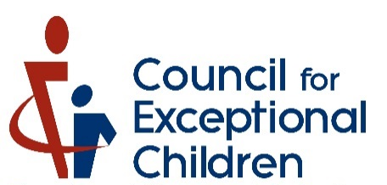

Official Charter

This is to certify that the

“State/Province”

“Name of Division”

Subdivision

has fully met the requirements of the Division Name
for recognition as an official subdivision thereof
and further that the Division Name hereby confers upon said group
all the rights, privileges, and obligations
accompanying such affiliation.

Authorized by the Division for Early Childhood Board of Directors
and declared effective as of this DATE.
This Charter shall be recorded
in the official records of the Division for Early Childhood.

_____________________________________________

John T. Doe, President

Division for Early Childhood

